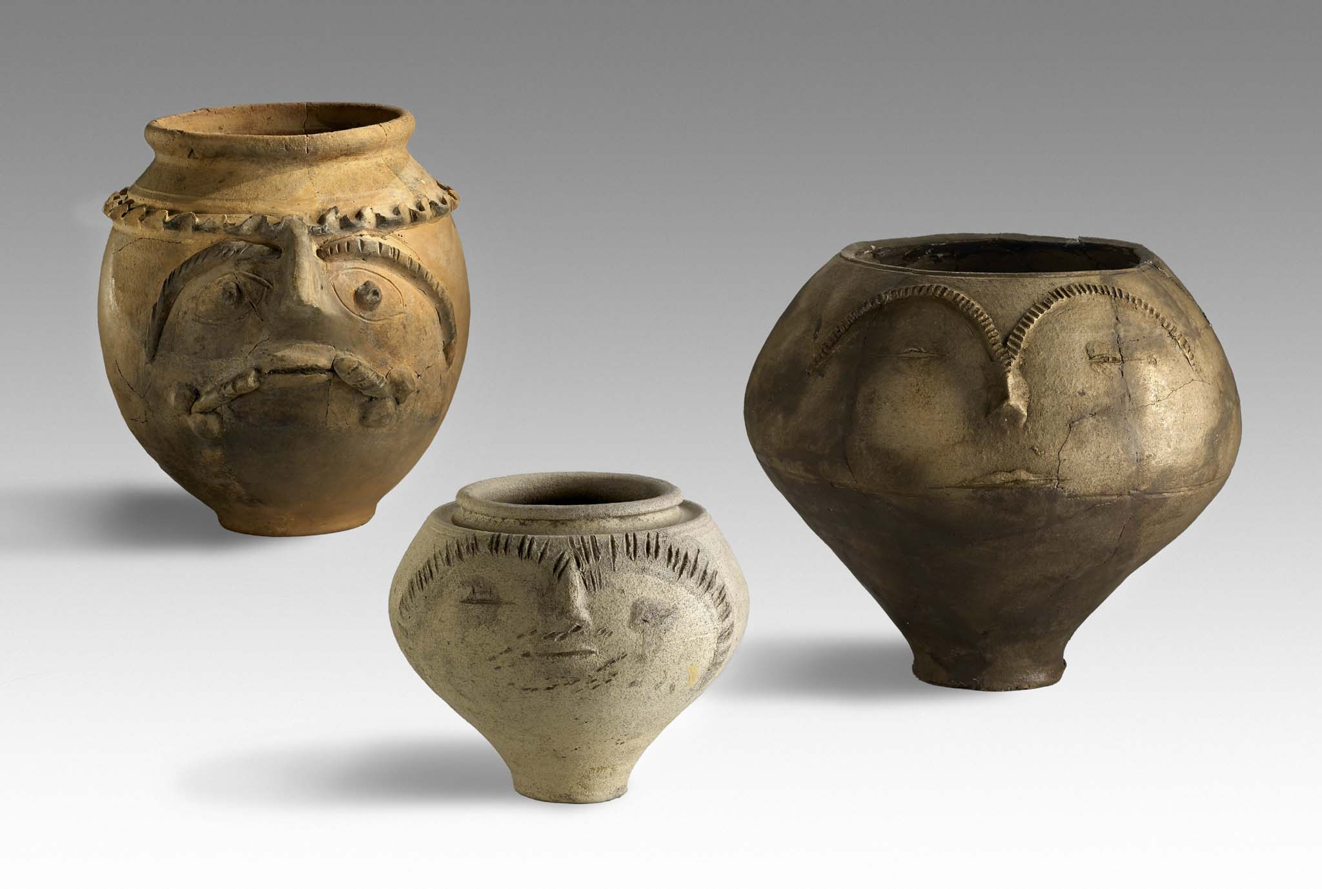
First Circular

29th Congress of the Rei Cretariae Romanae Fautores

Xanten, Germany, 21st – 26th September 2014

Welcome message

Dear Fautores, colleagues and friends,
It is our great honor to invite you to participate in the 29th congress of the RCRF 2014 at Xanten, Germany, from 21st to 26th September 2014. The conference will be organized by the team of the LVR-Archäologischer Park Xanten / LVR-RömerMuseum.

The RCRF seeks to promote research and communication on all forms of Roman pottery, including lamps. Thus the conference covers any kind of pottery in various sections. Participation is open to every scholar, not only to members of the RCRF. The number of participants is limited to 180, with priority given to members of the RCRF.

Xanten is located in the district of Wesel in the North-Rhine-Westfalia state of Germany. It is visited by about one million tourists a year. The LVR-Archäologischer Park Xanten is one of the largest archaeological open air museums in the world. Excavations have been taking place for centuries in the Roman town Colonia Ulpia Traiana and the legionary camps in the vicinity. Since 2008, the archaeological finds have had a new home: the LVR-RömerMuseum. Xanten was heavily destroyed in the Second World War. Many medieval buildings were restored, and today Xanten has a scenic city centre.

The Colonia Ulpia Traiana was a major town of the province Germania inferior. Together with the remains of the fortresses, the harbour installations and the cemeteries it forms an archaological zone of exceptional importance. In the Roman town and in the legionary fortress Vetera castra numerous remains of pottery workshops have been found.

General Information

Key Dates
Start Date: 21st September 2014
End Date: 26th September 2014
Post Congress Tour Date: 27th September 2014
Registration Deadline: 15th January 2014
Abstract Submission Deadline: 15th June 2014
Poster Submission Deadline: 15th July 2014
Manuscript Submission Deadline (for publication): 31st December 2014

Venue
LVR-Archäologischer Park Xanten / LVR-RömerMuseum
Siegfriedstraße 39
46509 Xanten
Germany
GPS 51.667764 N / 6.438332 E.
www.apx.lvr.de

Lectures will take place in the auditorium of the LVR-RömerMuseum.

Arrivals are expected on Sunday (21st September), and for those participating in the post-congress tour departure will be on Saturday (27th September, late afternoon). Participants will need to make their own accommodation arrangements. Early booking is strongly recommended. Detailed information will be available on the website.

Official languages are English, French, German, Italian and Spanish. Bullet-point summaries in English on PowerPoint slides are helpful in understanding non-English lectures.

Lectures should generally be of 15 minutes duration. Please note that only PowerPoint presentations will be accepted. No more than one lecture will be accepted from any one participant. For reasons of better visibility, drawings of vessel profiles should be filled. Submitting authors have the option of stating their presentation preference – oral or poster – but the program committee will make the final decision. As the number of lectures is limited, delegates are kindly encouraged to prepare a poster whenever possible. The organizers intend to provide an opportunity to print posters in advance at Xanten.

A small number of grants may be available from the RCRF in order to help those who would otherwise be prevented by financial hardship from attending the congress. Grants will generally be confined to the congress fee, but may exceptionally cover accommodation and travel costs in addition. Accommodation costs will be awarded on the scale of simple hostel accommodation and travel will be expected to be the cheapest obtainable.

Programme

Selections of pottery produced at various kiln sites in Lower Germany will be on display. A small exhibition at the LVR-RömerMuseum is dedicated to the history of pottery production and trade in Germania inferior and beyond.

An integral part of the congress scientific programme are guided tours at Xanten as well as excursions (included in the registration fee) to Haltern am See and Nijmegen (The Netherlands). Participants can join a tour to the LWL-Römermuseum at Haltern am See. The LWL-Römermuseum contains a rich collection of archaeological finds from the Augustan legionary fortress. The tour to Nijmegen will take you to Radboud University and to Museum Het Valkhof. Museum Het Valkhof houses a large number of objects from archaeological sites at Nijmegen.

To finish off the conference days the organizers intend to arrange an optional one-day post congress excursion to Cologne. The Colonia Claudia Ara Agrippinensium was the capital of the province Lower Germany. The remains of the praetorium, the town wall and other public buildings will be of some interest to participants. The Römisch-Germanisches Museum is dedicated to art and culture of Germania inferior. It houses many famous pieces as well as more recent archeological finds excavated by the Archeological Service of the city of Cologne.

Contact

If you wish to join the conference, please fill in the registration form and send it via mail or email to

Dr. Bernd Liesen
LVR-Archäologischer Park Xanten
Trajanstr. 4
46509 Xanten
Germany

E-Mail: RCRF-29.apx@lvr.de

The closing date for registration is now 15th January 2014. A second circular with more detailed information will be forwarded in February 2014 to registered persons.

Please pass a copy of this circular to any interested person.

http://www.apx.de/english/archaeologicalpark/research/congressofrcrf.htm
http://www.fautores.org/pages/congress_2014_Xanten.htm

